**A CRM Application to Manage the Mall**

# Project Overview

This project is focused on A CRM Application to Manage the Mall, designed to address Customizing Salesforce to meet diverse tenant needs and integrating multiple data sources securely. The goal is to deliver a comprehensive solution by leveraging Salesforce Customization, Advanced Analytics and Reporting, Automation and Workflow Optimization, Real-Time Data Integration, Scalable Architecture. Through this project, we aim to enhance Centralized Management, Improved Tenant Relations Data-Driven Decisions, Automation, Enhanced Customer Experience, Scalability and support the long-term goals of Scalability for Growth, Sustainable Tenant Relationships. Data Security and Compliance, Continuous Innovation, Operational Efficiency, Customer-Centric Strategies, Analytics-Driven Improvements.

# Objectives

**Business Goals**: The project aims to enhance operational efficiency, improve tenant and customer relationships, enable data-driven decision-making, and drive overall mall profitability and growth.

**Specific Outcomes**: Key deliverables include a customized CRM system with seamless integrations, real-time analytics, personalized engagement tools, and secure data management, ensuring improved operational efficiency and stakeholder satisfaction.

**User Adoption:** Achieve 95% active usage among mall staff and key stakeholders within six months of implementation

**Customer Engagement:** Increase tenant satisfaction scores by 20% and customer retention rates by 15% within the first year.

**Data Accuracy:** Maintain 99% data accuracy in the CRM system with quarterly data audits.

# Salesforce Key Features and Concepts Utilized

The Salesforce CRM for mall management leverages key features and concepts such as standard and custom objects for tenant and retail space management, automation tools like Flow Builder and Process Builder for streamlining processes, and integration solutions using APIs or MuleSoft for seamless connectivity with existing systems. It utilizes Analytics and Einstein AI for real-time insights, Marketing Cloud for personalized engagement, and Experience Cloud for tenant portals and collaboration via Chatter. Security is ensured with role-based access controls and Shield Encryption, while Service Cloud and a Knowledge Base enhance customer and tenant support. Customization through Apex and Lightning Web Components ensures scalability, with mobile access enabling on-the-go management.

# Detailed Steps to Solution Design

**Step 1: Requirement Gathering and Analysis**

1. Identify stakeholders (mall admin, tenants, customers, staff) and their requirements.
2. Document business processes such as tenant onboarding, lease management, event scheduling, and customer engagement.
3. Define specific, measurable goals the CRM must achieve (e.g., increase tenant retention by 15%).
4. Create use cases and user stories for different functionalities (e.g., "As a tenant, I want to view my lease details through a portal").

**Step 2: Design the Data Model**

1. Define core entities like **Tenants**, **Leases**, **Retail Spaces**, **Events**, and **Customers**.
2. Map relationships between these entities (e.g., one Tenant → many Leases).
3. Extend Salesforce standard objects (e.g., Accounts, Contacts) or create custom objects to represent mall-specific entities.
4. Add fields (standard/custom) to capture essential data (e.g., Lease Duration, Payment Status).
5. Visualize the data structure using **Salesforce Schema Builder** or ERD diagrams.

**Step 3: User Interface (UI) Design**

1. Use **Lightning App Builder** to design intuitive, role-specific page layouts for staff, tenants, and admins.
2. Create **Lightning Record Pages** with relevant components like tenant lease details and payment history.
3. Design **Dashboards** and **Reports** to visualize KPIs such as tenant occupancy and revenue trends.
4. Build **Experience Cloud Portals** for tenants to access their lease information, submit support requests, and view invoices.
5. Ensure responsive design for compatibility across devices.

**Step 4: Business Logic and Automation**

1. Automate routine tasks using **Flow Builder**, **Process Builder**, or Apex (e.g., sending lease renewal reminders).
2. Configure validation rules to maintain data integrity (e.g., valid lease start and end dates).
3. Set up approval processes for critical workflows (e.g., tenant application approvals).
4. Create triggers in Apex for custom scenarios (e.g., calculating shared maintenance costs).

**Step 5: Integration Design**

1. Identify external systems for integration (POS, facility management, marketing tools).
2. Use **Salesforce APIs**, **MuleSoft**, or AppExchange solutions for seamless connectivity.
3. Plan real-time data synchronization for accurate reporting and operations.
4. Test integration workflows to ensure compatibility and data integrity.

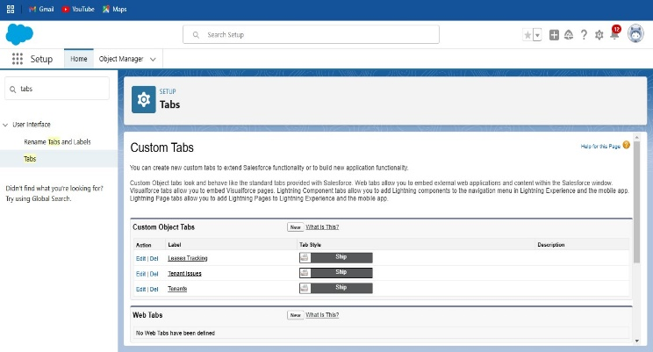

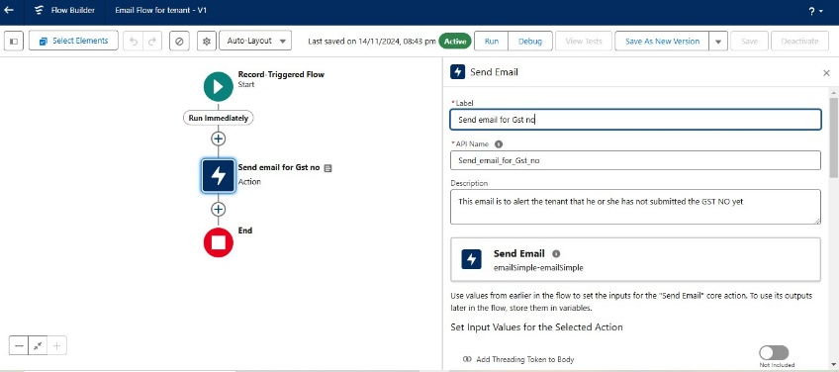

# Testing and Validation

**Step 1: Define Testing Scope and Objectives**

1. Validate that all functionalities align with business requirements and workflows.
2. Ensure the solution is scalable, secure, and performs optimally across user scenarios.
3. Test integrations, automation, and user interfaces thoroughly to prevent disruptions.
   * .

**Step 2: Testing Process**

1. **Prepare Test Cases**
   * Create detailed test cases for each feature or scenario.
   * Example: *"When a lease is about to expire, an automated email is sent to the tenant 30 days before the end date."*
2. **Set Up Test Environment**
   * Use a Salesforce **Sandbox** to replicate the production environment.
   * Populate with sample data for realistic testing.
3. **Execute Tests**
   * Run tests according to the test plan and record results.
   * Document issues, bugs, or performance gaps for resolution.
4. **Log and Fix Bugs**
   * Track issues using tools like JIRA or Salesforce itself.
   * Assign to developers for resolution and re-test once fixed.
5. **Validate Fixes**
   * Retest resolved issues to confirm functionality and compatibility.

**Step 3: Final Validation**

1. Conduct comprehensive UAT to validate the solution against user needs.
2. Obtain sign-off from stakeholders confirming the system meets requirements.
3. Perform a final round of testing in the production environment post-deployment.

**Step 4: Documentation and Reporting**

1. Compile testing results, including test cases, issues, fixes, and final validation.
2. Create a Testing Summary Report detailing:
   * Pass/fail rates for test cases.
   * Key resolved and unresolved issues.
   * Recommendations for ongoing monitoring and maintenance.

**Step 5: Post-Deployment Monitoring**

1. Monitor system performance and user feedback after go-live.
2. Address any issues or optimizations as part of continuous improvement.

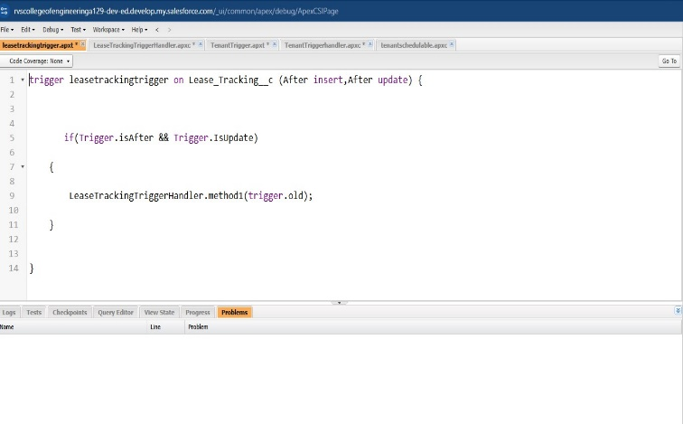

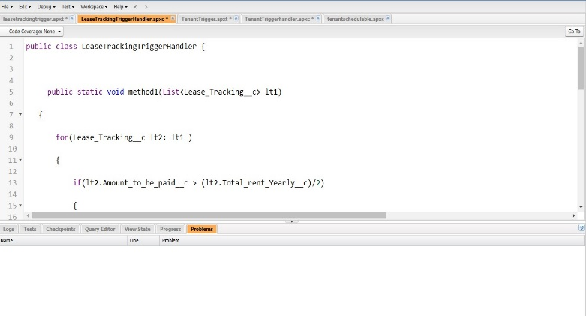

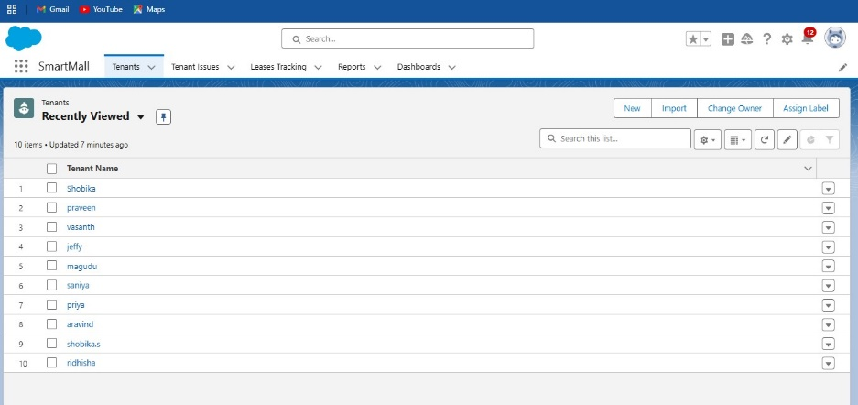

# Key Scenarios Addressed by Salesforce in the Implementation Project

Salesforce CRM addresses key scenarios in mall management, including:

1. **Tenant Onboarding and Management:** Automates lease tracking, renewals, and payments.
2. **Customer Engagement:** Personalizes marketing campaigns and event promotions using Marketing Cloud.
3. **Event Management:** Tracks events, customer registrations, and promotions.
4. **Facility Maintenance:** Manages tenant service requests via Service Cloud.
5. **Data-Driven Insights:** Provides dashboards and reports for performance tracking and decision-making.
6. **Security:** Ensures role-based access control and data encryption.
7. **Customer Support:** Handles inquiries and cases through Service Cloud, with self-service options.
8. **Compliance and Reporting:** Tracks compliance and business performance with custom reports.
9. **Mobile Access:** Allows remote access for managers and tenants via the Salesforce Mobile App.

# Conclusion

**Summary of Achievements:** In conclusion, Salesforce CRM streamlines mall management by automating tenant onboarding, lease tracking, customer engagement, and event management. It provides real-time insights, enhances collaboration, and ensures security and compliance. With mobile access and seamless integrations, Salesforce improves operational efficiency and offers a scalable, user-friendly solution for mall managers, tenants, and customers, fostering a more connected and efficient environment.